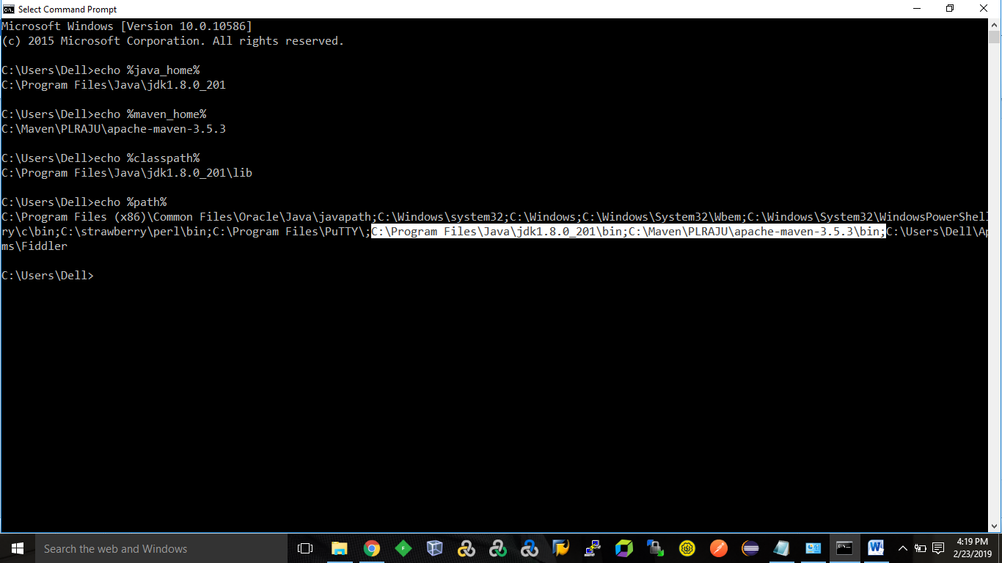

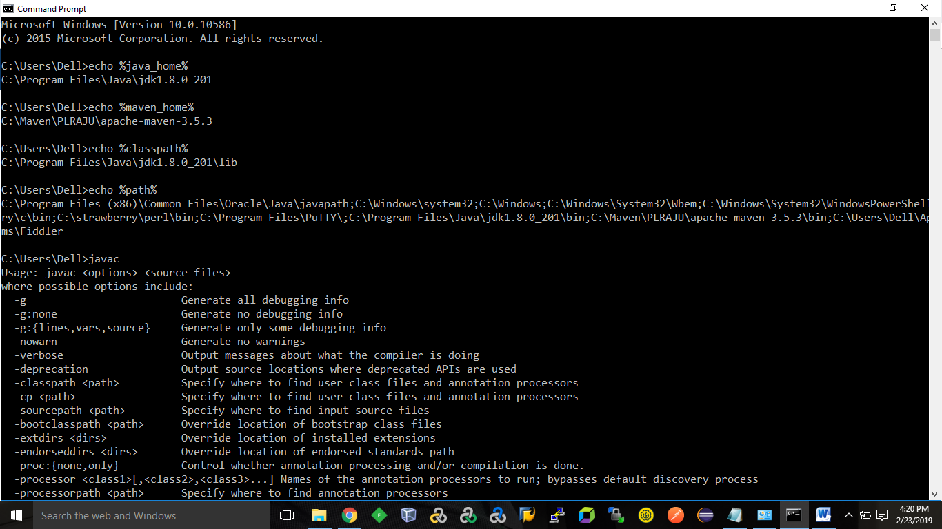

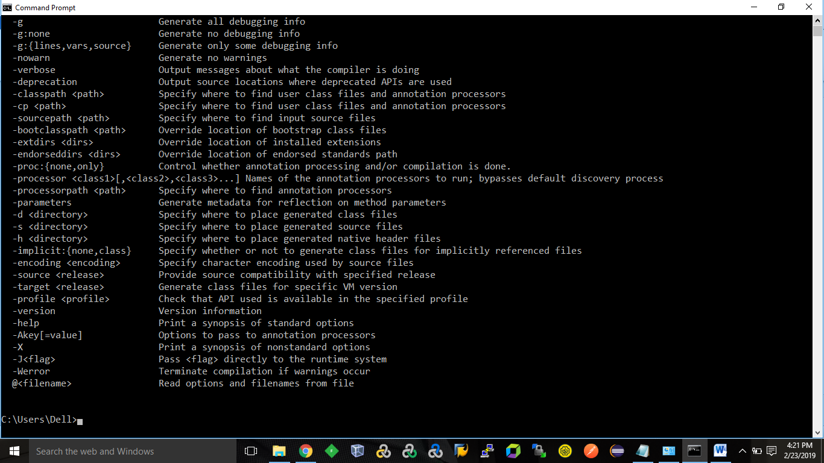

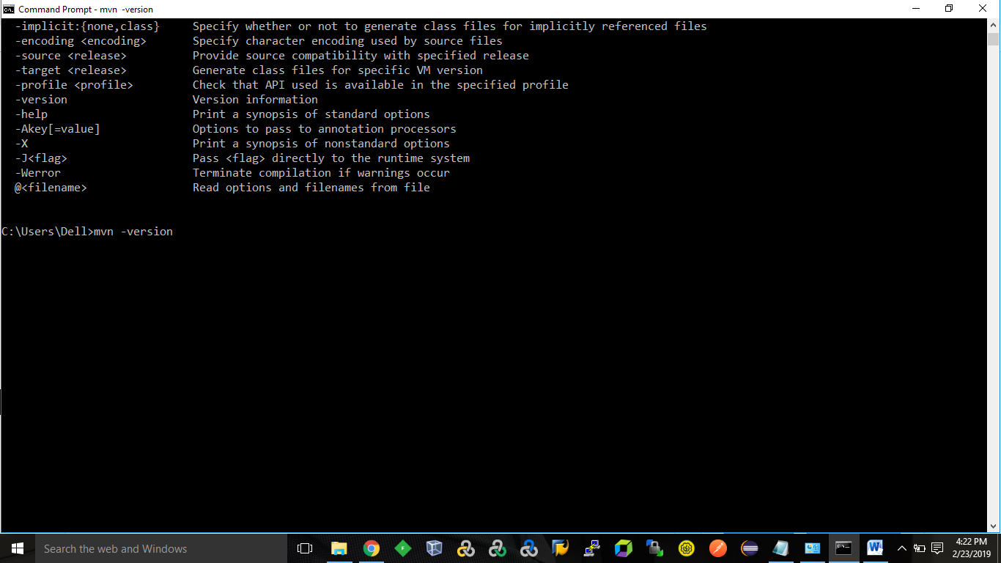

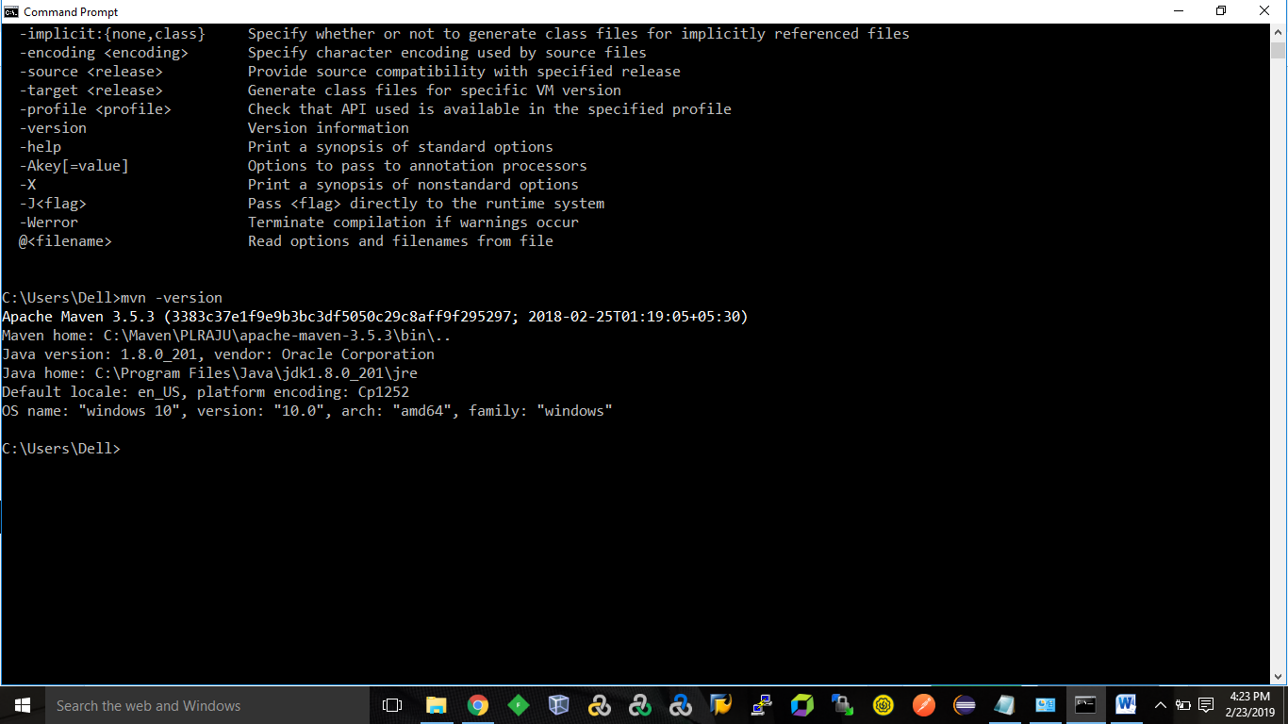

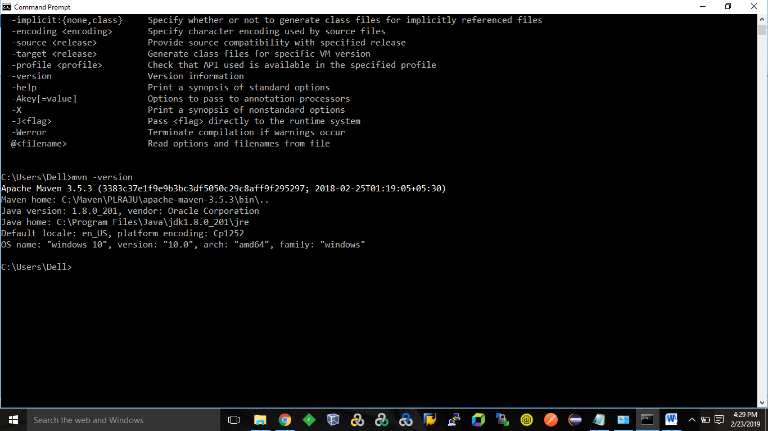

<https://stackoverflow.com/questions/15265277/how-to-start-jenkins-on-different-port-rather-than-8080-using-command-prompt-in/28695948>

<https://subscription.packtpub.com/book/networking_and_servers/9781788297943/1/ch01lvl1sec19/using-different-ports-for-jenkins>

